**Personal Expense Tracker**

**Introduction**

While we cannot control our salaries, we can track our expenses and monitor our cash flow. More often than you think credit happens because of poor budgeting and bad management of the financial budget. You can have better control over how much you spend if you have an automatic system. The system should be apt in keeping track of your credit card and debit card and process its transactions systematically. [Automated expense tracker software](https://www.wellybox.com/expense-tracker-software/) makes the process of tracking each expense much easier.

Every individual and business has designated end goals, whether they are monthly or annual or for any period of time. It is natural to expect our bank accounts to be able to match the life we want to perceive. Expense tracker apps help you identify where each category of expenses. They help you be aware of how much you need to save every month to bridge this gap.

Maintaining a copy of your receipts isn’t the same as financial management. Sure, you can save your expense and cash records manually but you won’t be aware of where you can save. Tracking your expenses help you identify your biggest debt sources. This helps you make informed decisions on how much you spend. A good expense tracker app would have additional features as well such as monthly reports, saving receipts, tips to budget better, record income from other sources and so much more. The app should be perfected to suit your business. Opt for an option that’s customized to work seamlessly so that your money tracking and expenses aren’t mental calculations on the fly.

**Importance of Expense Tracking**

* According to a survey, [26%](https://www.canada.ca/en/financial-consumer-agency/programs/research/financial-well-being-survey-results.html) of Canadians had a Financial Well-Being Score of less than 50.
* Out of this 26%, about 19% have a score between 31 and 50 and are somewhat struggling while 7% have a score of less than 30 and are struggling a lot.

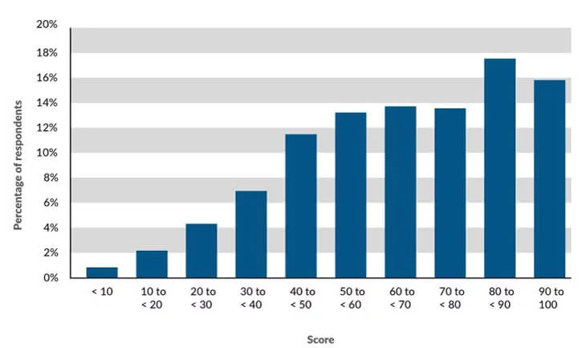

Source: canada.ca

* The study also said that Canadians who actively save have higher levels of financial well-being than those with the same income who don’t.
* In fact, intentionally setting money aside is the variable most strongly related to financial well-being, regardless of income level or other demographic influences.
* In the USA, 45.5% of people do not have any savings for their retirement. They will essentially be broke when they retire.

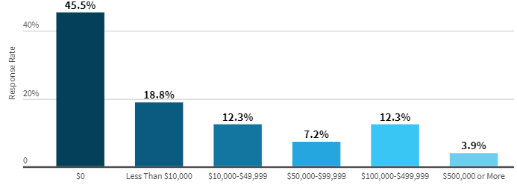

These facts suggest how serious it is to save money. These problems arise as people do realize the future repercussions of not tracking money.

**Features:**

**Track Income and Expenses**This goes without saying. The main feature of an expense tracker app is monitoring income closely and keeping a check on expenses against it.   
You can easily import transactions from your bank, credit card, mobile wallets without risking your information.   
This gives a clear image of how much you are making and how much you are spending. You can easily have an idea if your spending habits are feasible or in accordance with your income.

**Capture and Organize Receipts**You tend to miss out on adding certain transactions or forget about some expenditures altogether. This problem is solved with this component.  
You just need to capture an image of the receipt every time you do or receive a digital or cash payment. Put it under the appropriate category and the spending tracker will make sure you don’t forget it.   
The images are stored on a cloud and you don’t lose it either. In fact, the receipts are organized in such a way that you can retrieve them any time you want.

**Organize Tax Deductions**When it comes to filing taxes, just import your document to a finance tracking app. The app will easily organize income and expenses into tax categories.  
Spending tracking apps will sort your business expenditures into the appropriate tax categories, helping you keep more of what you earn.

**Accept Payments and Manage Invoice**The expense tracking app will accept credit cards, debit cards, net banking, and bank transfers directly in the invoice.  You can also track the status of your invoices and credit card bills from the app itself.   
The app sends payment reminders and automatically matches payments to invoices. If you want you can also create professional custom invoices with your logo that you can send from any device.

**Run Reports**The daily expenses app also lets you generate and run reports of profit & loss, income, expenses, and balance sheets. You can also create a custom report so that you get important insights about your individual business needs.  
If needed, you can for advance reports and generate budgeting and inventory reports.

**Track Sales**Use your expense tracker app as an e-commerce solution as well. You can accept credit cards by integrating a feature of a mobile card reader and also have an option to sync with popular apps.  
You can also connect to e-commerce APIs that you prefer using. The finance tracking app automatically calculates taxes on your invoice.

**Manage Vendors and Contractors**You can add details of vendors and contractors in the app and assign them categories. Also, keep track of all the payments you have made to these vendors- who, how much and when you have made the payments.

**Secure Access**You are not going to handle all the transactions yourself, you can give your accountant secure access to your books. You can also give specific access to certain functionalities of the expense management software to reduce errors.  
The best budgeting apps help in assigning work to particular users and increase your team’s productivity. Moreover, you may create custom permissions for deposits, sales transactions, expense reports, balance sheets, take care of personal capital and more.  
This helps the entire team to stay on the same page by sharing reports yet, without compromising the security of sensitive data.

**Track Projects**Best budgeting apps let you keep track of the activities of all your projects, all in one place. Further, you can track your resources that are being utilized on the various aspects of your project.  
You can keep track of labour costs, payroll, and expenses with job costing. This leads to determining project profitability with just one glance on the dashboard and reports.

**Track Inventory**People develop special inventory management software for their business but your expense tracker app for business can track your inventory for you.   
This one helps track products, cost of goods, and sends alert notifications when inventory is running low on a product. You can also see which product is popular and which is not selling as per the need.   
The expense tracking app lets you create purchase orders and handle vendors as well. In fact, you can directly import from the existing spreadsheet so you don’t have to put all the details again.

**Analytics and Insights**This feature lets you create presentation-ready and customizable reports which also have easy-to-understand visuals and graphs. You can also analyze these reports to generate insights.   
The best budgeting apps also come with in-depth analysis tools using which you can see how well your business is performing. You can also compare the past and present reports and predict future sales.

**Recurrent Expenses**The best budgeting software can also track certain bill payments and vendor transactions that occur at regular intervals. You can give access to the app to take care of such recurrent expenses.   
This will streamline and automate repetitive expenses, checks, and invoicing tasks.

**Automate Workflows**This one saves a ton of your time that you would usually spend in making reports, sharing and analyzing. You can configure reminders that send alerts based on the needs of your business solutions.   
These automated reminders also improve sales, client relationships and cashflow.

**Additional special features:**

**Micro-Investing**

This feature or functionality helps you invest in small amounts. So, there is no headache in thinking about larger investment solutions. You can do manual investments or easily automate monthly investments as per your account balance.

**Credit Monitoring**

This feature showcases present credit scores, updated weekly scores, and offers the score a rating like good or fair. Improvement in a similar element will give notifications about credit score change through customized recommendations and push notifications for credit items, depending on your present credit score.

**Chatbots**

Chatbots are engaging and amazing messaging interfaces. You don’t require learning the ways of using other applications. You can simply talk to the bot like you do with others.

Chatbots are completely equipped to understand all your requirements and questions. This feature of an expense tracking app helps monitor your account balance seamlessly.

**Travel Budgeting**

This feature helps make a budget before an employee goes on a business tour. You can add the tour destination and get a graph or chart made as per their convenience. Then, you can allocate resources depending on the expected travel expenditures. This will help you save lots of money invested in business trips.

**Discounts**

This feature helps in saving by giving discounts on products you require depending on your choices when you need them.

Moreover, it discovers and showcases unique discounts on products you want to purchase or find less costly substitutes to the same products close to the time of buying. This app does not just tell how to save money but also provides solutions for saving it.

**Prediction Analysis**

Artificial Intelligence knows your finances, expense behavior, and predicts your further purchases. Also, it provides unique info about how to save money.

From how much to spend to where to spend your money, you will learn all the factors that can lead to fluctuations in your expenditures.

**Advantages of expense tracking**

Still on the fence about whether your business needs an app for expense tracking? A dedicated app for expense tracking offers much more features than you can imagine for businesses of all sizes and even personal use.

**Savings for goals**

If you track your expenses regularly, you’d not only know where your money is going but also help be more disciplined in savings. An app that understands your bank account, income, and expenses helps you decide how much you need to save every month. For example, you can set a desired money-related goal and then input how much you spend money. By tracking each expense, a small business can easily get a simplified prediction of the time needed to buy a new asset. Features such as the predictive date for what month your goal security would be in your bank account are extremely useful.

The app you select should be able to automatically advise and highlight your largest expenses. This runs like how credit cards work by tracking your spending across the month. All you need to do is highlight each expense, enter it manually or use OCR technology and let the artificial intelligence do the rest. Let’s say you wish to upgrade the desktops in your work and that needs about 6000$ in spending money. The app predicts if you track your spending, you should hit that goal in just 7 weeks by just saving 857$ a week. This way your financial budget doesn’t drastically change and you can focus on new ways to make money rather than fall into the trap of credit purchases.

**Developing good financial discipline**

An [expense tracking app](https://cllax.com/top-10-best-expenses-management-software.html) also introduces financial discipline to keep an eye on your expenses. Often with credit cards since expense tracking comes only monthly, we get the illusion of unlimited finances. There is little care about the debt until it costs our accounts to dip into debt. Tracking expenses via an app introduces a layer of budgeting by getting not just monthly summaries by instantly accessible financial reports. You create your own rules and the app gives you advice along the way.

The process sounds simple but it accounts for preparing better for the future. As a business owner, your goal is to ultimately reduce your expenses or at least track your expenses and increase profits. Having good discipline via knowing your worth and expenses helps in the process of self-evaluation.

**Investments and savings**

Do you dip into your emergency funds more frequently than you had anticipated? Does your budget keep overshooting and your team cannot figure out why? This is where expense manager apps come in handy by sorting your investments and savings in a much easier way.

Once you input your costs, you can see in a visually understandable simpler way how much things cost and what purchases you incur. This helps make informed, calculated decisions on your next purchase. When you divide expenses via categories it becomes easier to manage what costs can be cut down. For example, you may see one category, let’s say utilities costing you more than it should. You would be able to easily spot this compared to a manually typed bland excel file.

**Saving time**

Time is indeed money when it comes to finances. Costs don’t stop regardless of your business speed. It becomes easier to manage the working of your business when you can dedicate some tasks to automation. Some apps designed to monitor the number of finances you spend are smart enough to use minimum clicks giving you time to focus on other things.

Imagine not dedicating several hours/days every month to tell your finance manager to account for every income and expenditure. The time you save from going through your debit card and credit card’s statements can be better utilized in much more important ways. Teaching the staff to learn to use the expense manager apps leaves them free to dedicate their resources elsewhere.

**Better competitive advantage**

In today’s day and age of competitive business practices, you may find yourself confused with how to differentiate your business from your peers. This is why adding even behind-the-scenes features such as money tracking sends a positive image to your customers. Clients may look at your business as modern as they represent if you use apps to track your expenses.

There are dozens of apps to choose from, some even offering their income spending management features for free. But budgeting apps need to be catered to your modern style of working. It is statistically known you’d end up using your phone much more. That’s why it’s a smart idea that your apps are also on your phone. Imagine getting a notification about how much your team spent or the cost of the new paper is more than what you paid last month. This helps create a new way for you to manage the security and track money spent.

**Reference:**

 1. Expense Tracker-MAY 2021 | IRE Journals | Volume 4 Issue 11 | ISSN: 2456-8880

2. A Novel Expense Tracker using Statistical Analysis Muskaan Sharma1 , Ayush Bansal2 , Dr. Raju Ranjan3 , Shivam Sethi4 1,2,3,4School of Computer Science and Engineering, Galgotias University

3.https://www.spaceo.ca/blog/expense-tracking-apps-streamline-finance-management/

4.Daily Expense Tracker Shivam Mehra, Prabhat Parashar UG Student, Department of Computer Science and Engineering HMR Institute of Technology and Management, Delhi, India

5. <https://www.southtechgroup.com/expense-tracker-app/>

6.<https://onplanners.com/template/everyday-expense-tracker>